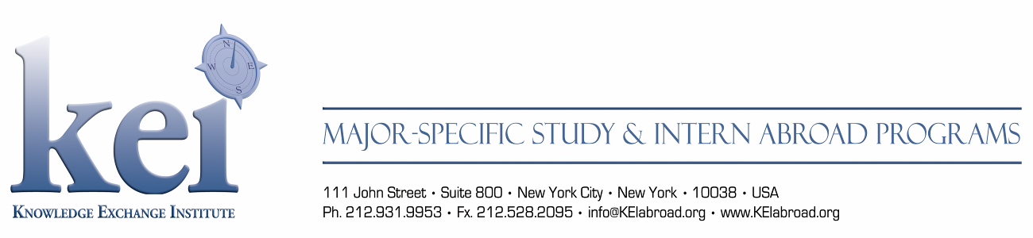

SYLLABUS:

LAN 101-303 Russian Language
Students will be tested to determine the level of Russian Language. The language program has been designed at different levels to accommodate students possessing zero level of Russian to advanced students. During the semester, each Russian language course is 180 to 240 contact hours. During the summer, each Russian language course is 50 to 60 contact hours.

Credits: 9-12 (semester); 3-4 (summer)
Text: depends on level

LAN 101 Russian Language (Beginner I)
This course aims to help the student to acquire some knowledge of basic Russian, so that s/he can communicate with Russians, using basic vocabulary and grammar to express him/herself.
Prerequisites: none

LAN 102 Russian Language (Beginner II)
This course includes more advanced grammatical structures. Elementary vocabulary is expanded to further develop communicative skills.
Prerequisites: LAN 101 or equivalent

LAN 201 Russian Language (Intermediate I)
This course aims to help the students enhance their knowledge of Russian language and expand their vocabulary.
Prerequisites: LAN 102 or equivalent

LAN 202 Russian Language (Intermediate II)
Students taking this course will be able to improve their knowledge of Russian grammar, expand their vocabulary and learn different styles of expression. They will become acquainted with the highlights of classical and modern Russian literature.
Prerequisites: LAN 201 or equivalent

LAN 301 Russian Language (Advanced)
This course suits the needs of students who would like to achieve proficiency in communicative skills, to master grammar and to enrich their vocabulary. It is also for teachers of Russian as a foreign language who want to improve their professional competence.
Prerequisites: LAN 202 or equivalent

